

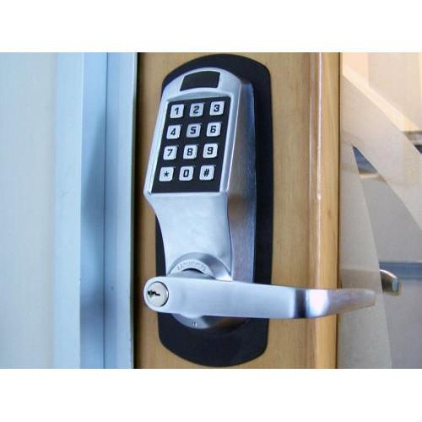

# DOOR SECURITY CONTROL

## Submitted by: Group 55

### Group Members

### 2018B3AA0737G Harsh Lodha

### 2018B4A80046G Harsh Talwar

### 2018B3AA0791G Kanan Arora

### 2018B3A70750G Rishabh Chheda

### 2018B3A80770G Saurabh Raj

### 2018B4AA0839G Soumya A Thomas

Date: 19/4/2021

Contents

User Requirements & Technical Specifications 2

Assumptions & Justifications 2

Justification 2

Assumptions 2

Components 3

Address Map 4

Memory Map 4

I/O Map 4

Design 5

Flow Chart 6

Main Program 6

Flow Chart of ISR 7

ADC ISR 8

Variations in Proteus Implementation 9

Firmware 10

List of Attachments

**USER REQUIREMENTS AND TECHNICAL SPECIFICATIONS**

Description:

This system controls the opening and closing of a door based on password entry. If the password is correct the person can enter. Each person is given two chances to enter the correct password. On failure an alarm is sounded. Inside the room a button is available when the button is pressed the door opens for 1 minute, so that the person can leave the room.

User Interface:

There are three set of passwords:

(1) User

(2) Master

(3) Alarm off

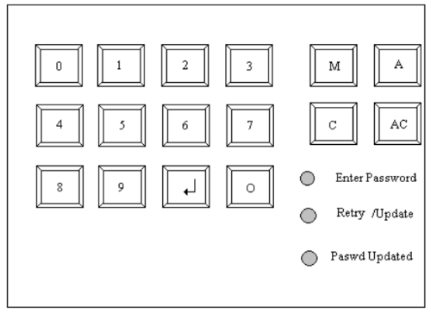

The Master password is used by the security Personnel for updating Password of the day. Pressing the M button activates this mode. The system glows Enter Password LED asking the personnel to enter the password. The master password is a 16-digit value. The master is given only a single chance to enter the password. If authenticated, the retry/Update LED glows. If there is a failure in authentication the alarm is sounded. When the retry/ Update LED glows the user has to enter the password of the day. This is a 12-digit value. Once this value has been accepted by the system the Passwd Updated LED glows.

User has to press the O key when he wants to enter the room. The Enter Password LED prompts the user to enter the password. The user is given C/AC option as well. If the first attempt fails, the RETRY LED glows. The user is allowed to re-enter password, and on authentication, the door opens for a period of 1 minute. On Failure an ALARM is sounded.

To Turn-off the Alarm the A button has to be pressed. Enter Password LED glows prompting the user to enter the 14-digit password for turning off the alarm, no retries are allowed. If authentication is successful then the alarm is turned off.

To leave the room a button is available inside the room, when the button is pressed the door opens for 1 Minute so that the person can leave the room.

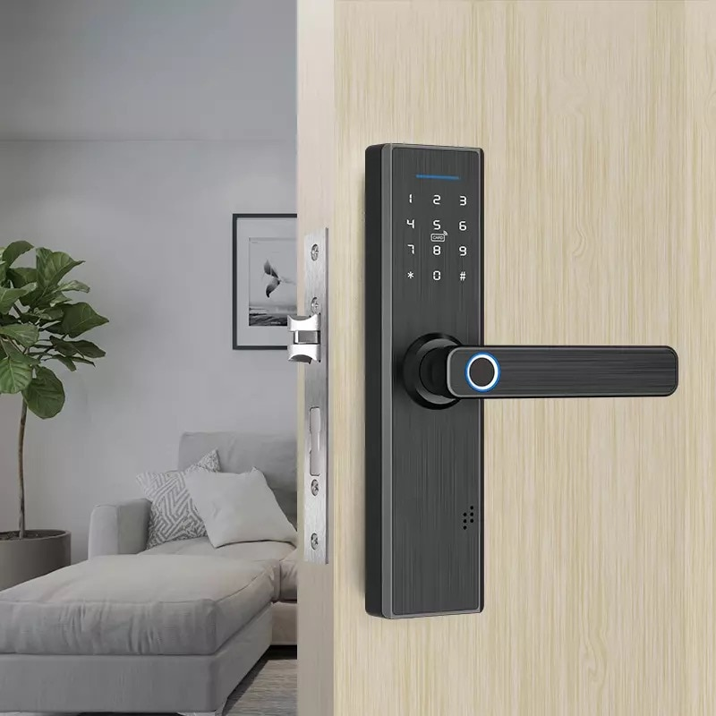

**Technical specifications**:

The stepper motor is connected to one of those latches which have a knob which rotates through 90 degrees to unlock it. The rotation of the knob back through 90 degrees in the opposite direction closes the latch. The door unlocks and the user will have to push it in-order to open the door. A user should not hold the door after entering as a door-closer is attached to the door in order to close the door after a user has entered through the door.

**ASSUMPTIONS AND JUSTIFICATIONS**

Assumptions:

1)The Master Password and Alarm Reset Password are hardcoded as given below:

**Master password:** 0123456789012345

**Alarm reset password:** 77777777777777

2) The 24 hour clock starts running when 8086 is first switched on, and subsequently computes 24 hours count. Therefore, the first action to be performed is to set the Password of the Day by Master in Master Mode.

3) Only one person may open and pass the door at a time.

4) User will not try to open the door from inside or outside, at the 24 hour mark. Interrupt for 24 hour completion and 1 minute door close will NOT occur at the same time. Hence, there is no need for a priority resolver such as the interrupt controller 8259.

5) Once a particular mode has been selected, User/Master must complete the procedure, i.e. M or O or A pressed within execution of a particular mode will have no effect.

6) If the wrong alarm reset password is entered by the user, the system will not respond to keypad entry until power is cut.

**COMPONENTS**

● 8086 (16 Bit Microprocessor)

● 74LS373 (Octal Latch) -To demultiplex address bus

● 8284 (Clock Generator)

● 74LS245(Transceiver)- To demultiplex data bus

● 74155 (2-4 Decoder) -To create chip select signals for RAM and ROM

● 7432 (OR Gates)

● 2716( ROM Chips)- 4 chips of 2K memory are used to make odd and even banks of memory to interface with 8086 at the starting address of FFFF0h and 00000h where IVT is stored.

● 6116 (RAM Chips) -2 chips of 2K memory are used to form odd and even banks to interface with 8086 and this memory is used for storage of temporary data.

● 74138 (3-8 Decoder) -to create chip select signals for 8255(2) and 8253(2)

● 8253 (Programmable Interval Timer) -for 1min and 24hrs timer

● 8255 (Programmable Peripheral Interface) - to interface leds,stepper motor,lcd display and hex keypad to microprocessor.

● Hex-Keypad - to take input (made using matrix of switches)

● LM016l LCD Display -to display various commands and errors

● PSM 57-81 2P Stepper Motor(MAXIM) - provides enough torque required to rotate the knob of the latch.

● C503B LEDs (RED) - For status indication through LEDs

● C503B LEDs (BLUE) - To indicate alarm is ringing

● ULN2003A Darlington Transistor -to interface relay(for alarm) and stepper motor to 8255

● Push Button/Switch - switch inside the room to open the door in-order to go out. ● 74LS241 Octal Tri-state Buffer

● ALARM(Buzzer) - To indicate wrong password is entered

**Address Map**

Memory Interfacing:

Size of ROM-2716 =2K

Size of RAM-6116 =2K

Total ROM size used=8K

Total RAM size used=4K

Address:

ROM1(even) = 00000h - 00FFEh

ROM1(odd) = 00001h – 00FFFh

ROM2(even) = FF000h - FFFFEh

ROM2(odd) = FF001h – FFFFFh

RAM(even) = 02000h - 01FFEh

RAM(odd) = 02001h – 01FFFh

I/O Mapping:

Address of 8255-1 port-A : 00h

Address of 8255-1 port-B : 02h

Address of 8255-1 port-C : 04h

Address of 8255-1 control register : 06h

Control word of 8255-1 : 88h

Address of 8255-2 port-A : 08h

Address of 8255-2 port-B : 0Ah

Address of 8255-2 port-C : 0Ch

Address of 8255-2 control register : 0Eh

Control word of 8255-2 : 89h

Address of 8253-1 count0 : 10h

Address of 8253-1 count1 : 12h

Address of 8253-1 count2 : 14h

Address of 8253-1 control register : 16h

Control word of 8253-1 count0 : 36h

Control word of 8253-1 count1 : 56h

Control word of 8253-1 count2 : 92h

Address of 8253-2 count0 : 18h

Address of 8253-2 count1 : 1Ah

Address of 8253-2 count2 : 1Ch

Address of 8253-2 control register : 1Eh

Control word of 8253-2 count0 : 34h

Control word of 8253-2 count1 : 5Ah

Control word of 8253-2 count2 : 94h

INTERRUPTS

NMI(Non-Maskable Interrupt)- In our implementation NMI is used for the 24

hour timer ,which helps the user to Update Day Pass every 24 hours.

INT 80h- This interrupt is used for helping the user to open door from

inside,as the push button is pressed.Octal Tri-state buffer is used to

generate the interrupt vector.When 8086 sends a low interrupt

acknowledge the Octal Tri-state buffer puts 80h on datalines.

|  |  |  |
| --- | --- | --- |
| Interrupt Vector No | Physical Address | Contains |
| INT 02h (NMI) | 00008h  0000Ah | IP2  CS2 |
| INT 80h | 00200h  00202h | IP128  CS128 |

**Counter Calculations** :

8253-1 counter 0 is fed with a 2.5Mhz frequency signal from 8284 p-clock.This is reduced further to 50Hz.

Out clock freq = In clock freq/count

Count = 50,000

This 50Hz clock signal is fed to 8253-1 counter 1 which is also configured in Mode 3 (Rate Generator).50Hz is further reduced to 0.5Hz by loading a count value of

50/0.5=**100**

**24 hour Timer** : This timer Operation is implemented by 8253-2 counter 0.

(Mode 2,Rate generator or Divide by N counter)

The clock to this counter is fed from the output of 8253-1 counter 1 which is configured in Mode 3(Square Wave Generator).The clock frequency applied to 8253-2 counter zero is 0.5Hz.

0.5*60*60*24 = **43200**

Thus by loading a count of 43200 in this counter a 24 hour timer is implemented. The out pin of this counter is inverted and fed to NMI pin of 8086. At the end of 24 hours a LOW-to-HIGH pulse is generated at NMI which triggers INT 02h.In response, 8086 branches to ISR meant for INT 02h(Nmi_24hrtimer) and activates the Master Mode Key(M) on the Keypad. “**UPDATE DAY PASS**” is flashed on the LCD module and the code dosen’t branch back until a new password for the user mode is set. On setting the new User password the system branches back to normal routine and the user is greeted with LCD flashing “**G55 MUP**”.

**1 minute Timer** : This timer operation is implemented using 8253-1 counter. This counter is fed with a clock frequency of 50Hz from 8253-1 counter 1 out pin.8253-1 counter 2 is configured in Mode 1(h/w re-Triggerable one shot timer).

50*60 = **3000**

Thus by loading a count of 3000 in 8253-1 counter 2 a 1 min timer is implemented. As soon as the open_door subroutine is called the timer is triggered by giving a LOW-HIGH-LOW pulse on its gate pin.On receiving this signal the out pin goes low(Logic 0).At the end of one minute,(count == 0) out pin goes high(Logic 1) and this out pin is polled at PC1 pin of 8255-2.At the end of 1 minute close_door subroutine is called and door closes.

***CODE DOCUMENTATION***

This is a brief description of the Subroutines.

|  |  |  |
| --- | --- | --- |
| S.No | Name | Description |
| 1 | clear_LCD | Clears the LCD Display |
| 2 | welcome_msg | Prints “ G55” |
| 3 | keypad_inp | Obtains the key pressed from the keypad |
| 4 | intmaster | Initiates the master sequence |
| 5 | intalarm | Initiates the alarm sequence |
| 6 | intuser | Initiates the user sequence |
| 7 | DELAY_20ms | 20 milliseconds delay |
| 8 | DELAY_0.04ms | 0.04 seconds delay |
| 9 | DELAY_max | Max time delay possible |
| 10 | pressenter_LCD | Prits “ Press Enter “ on LCD |
| 11 | Print_* | Prints “*” on LCD |
| 12 | open_door | Rotate motor 90 degrees to open it |
| 13 | close_door | Rotates motor 90 degrees in opposite direction to close |
| 14 | clear_1digit_LCD | Shifts pointer left by 1, prints space, shifts pointer lagain eft by 1 |
| 15 | error_msg | Prints “ ENTER 12 DIGITS” on LCD |
| 16 | retry_msg | Prints “ RETRY” on LCD |
| 17 | updateday_msg | Prints “ UPDATE DAY PASS” |